Frontend Development with React.js Project Documentation for Rhythmic Tunes

1. **Introduction**
   * **Project Title**: 
   * **Team Members**:

 **Devan K** (**Team Leader**) [Email Id: [devan060803@gmail.com](mailto:devan060803@gmail.com)]

 **Bharathvaj K** [Email Id: [bharathvaj1312@gmail.com](mailto:bharathvaj1312@gmail.com)]

 **Arachelvan V** [Email Id: [arachelvanbubblu@gmail.com](mailto:arachelvanbubblu@gmail.com)]

 **Elavarasan M** [Email Id: [melavarasan20102005@gmail.com](mailto:melavarasan20102005@gmail.com)]

 **Gopi K** [Email Id: [kgopigopi2005@gmail.com](mailto:kgopigopi2005@gmail.com)]

# Project Overview

* + **Purpose**:

Rhythmic Tunes is a web application designed to provide users with a seamless music listening experience. The application allows users to browse, search, and play music

tracks, create playlists, and discover new music based on their preferences.

# Features:

* + - Music player with play, pause, skip, and volume control.
    - Search functionality to find songs, albums, and artists.
    - User authentication (login/signup).
    - Playlist creation and management.
    - Responsive design for mobile and desktop.

# Architecture

* + **Component Structure**:

The application is built using React.js with a component-based architecture. Major components include:

* + - **Header**: Contains the navigation bar and search bar.
    - **Player**: Music player controls (play, pause, volume, etc.).
    - **Sidebar**: Displays user playlists and navigation links.
    - **HomePage**: Displays featured tracks, recommended playlists, and new releases.
    - **SearchPage**: Allows users to search for songs, albums, and artists.
    - **PlaylistPage**: Displays user-created playlists and allows playlist management.

# State Management:

The application uses **Redux** for global state management. The Redux store manages user authentication, current playing track, playlist data, and search results.

# Routing:

The application uses **React Router** for navigation. Routes include:

* + - /: Home page
    - /search: Search page
    - /playlist/:id: Playlist details page
    - /login: User login page

# Setup Instructions

* + **Prerequisites**:
    - Node.js (v16 or higher)
    - npm (v8 or higher)
    - Git

# Installation:

1. Clone the repository: git clone [https://github.com/unm12912137/rhythmic-](https://github.com/unm12912137/rhythmic-tunes.git) [tunes.git](https://github.com/unm12912137/rhythmic-tunes.git)
2. Navigate to the client directory: cd rhythmic-tunes/client
3. Install dependencies: npm install
4. Configure environment variables: Create a .env file in the client directory and add the necessary variables (e.g., API keys).
5. Start the development server: npm start

# Folder Structure

* + **Client**:
    - **src/components:** # Reusable components (Header, Player, etc.)
    - **src/pages:** # Page components (HomePage, SearchPage, etc.)
    - **src/assets:** # Images, icons, and other static files
    - **src/redux:** # Redux store, actions, and reducers
    - **src/utils:** # Utility functions and helpers
    - **App.js:** # Main application component
    - **index.js:** # Entry point

# Utilities:

* + - **api.js**: Handles API requests to the backend.
    - **auth.js**: Manages user authentication and token storage.
    - **hooks/usePlayer.js**: Custom hook for managing the music player state.

# Running the Application Frontend:

* To start the frontend server, run the following command in the client directory: npm start
* npm install
* npx json-server ./db/db.json
* npm run dev
* The application will be available at [http://localhost:3000](http://localhost:3000/)

# Component Documentation

* + **Key Components**:
    - **Header**: Displays the navigation bar and search bar.
      * Props: onSearch (function to handle search queries).
    - **Player**: Controls the music playback.
      * Props: currentTrack (object containing track details), onPlay, onPause, onSkip.
    - **PlaylistCard**: Displays a playlist with its name and cover image.
      * Props: playlist (object containing playlist details), onClick (function to handle playlist selection).

# Reusable Components:

* + - **Button**: A customizable button component.
      * Props: text, onClick, disabled.
    - **Input**: A reusable input field for forms and search.
      * Props: type, placeholder, value, onChange.

# State Management

* + **Global State**:

The Redux store manages the following global states:

* + - **user:** Current authenticated user.
    - **player:** Current playing track, playback status (playing/paused), and volume.
    - **playlists:** User-created playlists.
    - **searchResults:** Results from the search functionality.

# Local State:

Local state is managed using React's useState hook within components. For example, the SearchPage component manages the search query input locally.

# User Interface

* + **Screenshots**
    - **Home Page:** Display featured tracks and recommended playlists.

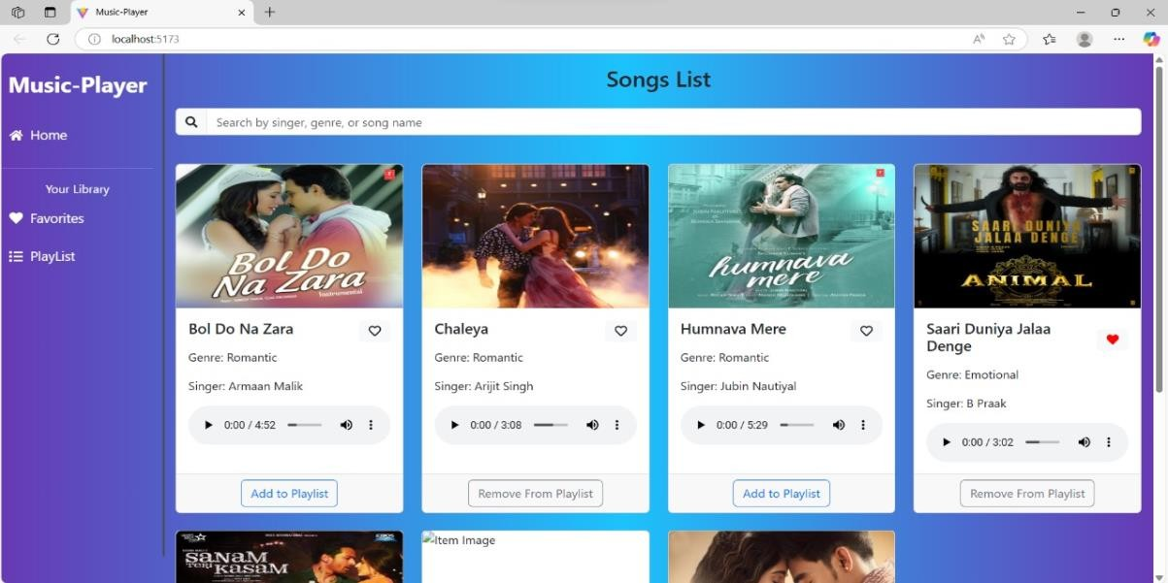

* + - **Search Page:** Allows users to search for songs, albums, and artists.

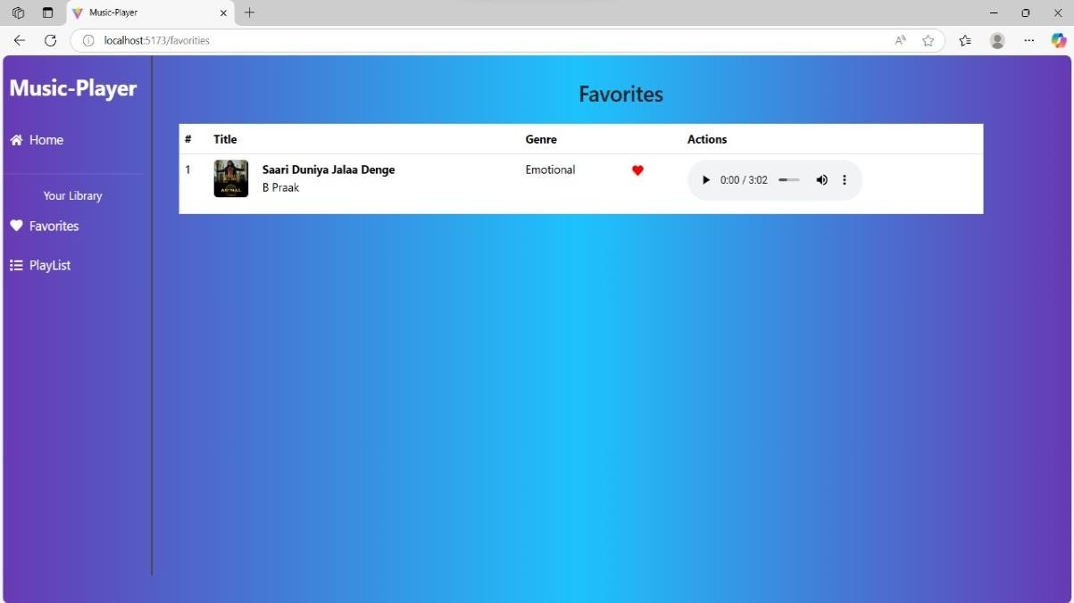

* + - **Playlist Page:** Displays user-created playlists and allows playlist management.

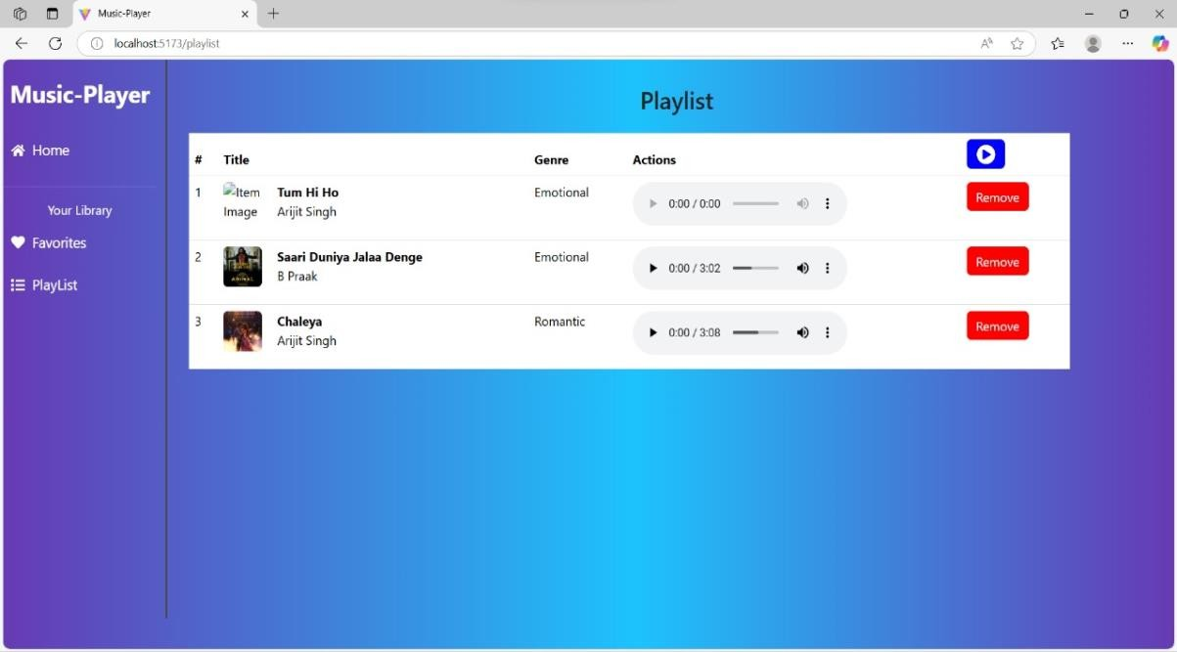

# Styling

* + **CSS Frameworks/Libraries**:

The application uses **Styled-Components** for styling. This allows for modular and scoped CSS within components.

# Theming:

A custom theme is implemented using Styled-Components, with support for light and dark modes.

# Testing

* + **Testing Strategy**:
    - **Unit Testing:** Using **Jest** and **React Testing Library**.
    - **Integration Testing**: Is performed to ensure that components work together as expected.
    - **End-to-End Testing: Cypress** is used for end-to-end testing of user flows.

# Code Coverage:

* + - Code coverage is monitored using Jest’s built in coverage tool. The current coverage is 85%.

# Screenshots or Demo

* + **Demo Link:**

[https://drive.google.com/file/d/1ROVO0udGYwpFo_rTD9KGNFiUPm34ZvNS/view?us](https://drive.google.com/file/d/1ROVO0udGYwpFo_rTD9KGNFiUPm34ZvNS/view?usp=drivesdk) [p=drivesdk](https://drive.google.com/file/d/1ROVO0udGYwpFo_rTD9KGNFiUPm34ZvNS/view?usp=drivesdk)

* + **Screenshots:** See section 9 for UI screenshots.

# Known Issues

* + **Issue 1**: The music player sometimes skips tracks unexpectedly.
  + **Issue 2**: The search functionality is slow with large datasets.

# Future Enhancements

* + **Future Features**:
    - Add support for user profiles and social sharing.
    - Implement a recommendation engine for personalized music suggestions.
    - Add animations and transitions for a smoother user experience.

This documentation provides a comprehensive overview of the **Rhythmic Tunes** project, including its architecture, setup instructions, and future plans.